DATE CREATED 7/8/2022 |  | CREATED BY Deanna Parker
VERSION NO. 2 |  | PROCESS OWNER Deanna Parker
DATE OF LAST REVISION 7/7/2022 |  | LAST UPDATED BY Deanna Parker
INSTRUCTIONS
- ‘I. INTRODUCTION’ – This section is utilized to provide detailed information about the document and the contents that is contained within the document. Information referenced in this document will provide details needed to understand the documented process and its deliverables.
  - Purpose: Provide the purpose of the document to include specific detail about what is being addressed with the development of this process
  - Scope: This section should outline the deliverables and/or objectives of this process to provide a method to measure success
  - Document Management: Describe how the document will be tracked, stored, and distributed.
  - Compliance: Provide all DOJ Provision and Compliance ID #s that are relevant or will be addressed by implementing the process on this document including language.
  - Roles & Responsibilities: Identify the role of all individuals involved in the process and define their responsibilities of each individual.
- ‘II. CHANGE CONTROL’ – This section will provide a description of the systematic approach to managing changes made to the process as well as ensuring that no unnecessary change or revisions are made that disrupt services or compliance.
  - Process Description – Provide a detailed description about the process and what the process will address (i.e. developed as a monitoring tool, lower budget expenses, etc.)
  - Input/Trigger – A process input/trigger describes what initiates the start of the process. Provide detailed information about what input is needed to start the process (i.e. intake process is initiated, a new service is begun, payment is received, etc.). The input/trigger should provide an explanation for the necessary tasks/steps identified in the process.
  - Outputs/Measures of Success – A process output/measure of success describes the expected end product of a process (i.e. report, improved performance metrics, etc.). Provide a statement that describes what the expected outputs/measure of success of the process should be. The description of this output should allow for the development or tracking of measures of success.
  - Boundaries – Process boundaries identify where the process starts and when it ends, it also identifies what is included and what is not included in the process. Boundaries also identify areas of intersect with other processes and activities. Provide any identified boundaries (i.e. initiation, closure, reporting cadence, frequency of process, etc.) in this section. Boundaries could include the intersection of where the process ends and the reporting process begins that includes the findings of the process.
  - Points of Control – Points of Control within a process identifies any action or event that could “block” the implementation of the process. Provide any foreseen obstacles that may impact successfully implementing the documented process
  - Version Control – Version Control will be utilized to track changes and guide naming conventions of process documents. Documents should follow the below nomenclature:
Program Area_Purpose_Ver_Version# (DQV_DOJ DQ Assessment_Ver_001)
- ‘III. Process’ – Provide detailed step-by-step instructions for implementation/execution of process.
- ‘IV. Verification’ – Provide all verification or validation process that needs to take place to ensure that the process is valid.
- ‘V. Continuous Quality Improvement (CQI)’ – Provide a detailed step-by-step process describing what will be done to monitor and improve process as time progresses.

I. INTRODUCTION
PURPOSE | To ensure that the Commonwealth implements the Quality Improvement System approved by CMS in the operation of its HCBS Waivers.
SCOPE | The CMS-approved Quality Improvement System in the DD HCBS waivers outlines:  - Inclusion of the evidence-based discovery activities that will be conducted for each of the six major waiver assurances.  - The remediation activities followed to correct individual problems identified in the implementation of each of the assurances.  - Identification of the Department and Division responsible for overall management of the respective QM function(s). DMAS, as the Single State Medicaid Agency, retains overall authority for the operation of the DD HCBS waivers in their entirety.  - Processes to oversee and monitor all components related to the QM Strategy.  - Identification of performance measures that will be assessed.  - Processes to review performance trends, patterns, and outcomes to establish quality improvement priorities.  - Processes to recommend changes to policies, procedures and practices, waivers, and regulation as informed through ongoing review of data.  - Processes to ensure remediation activities are completed and to evaluate their effectiveness.  - Processes to report progress and recommendations to CMS for continuation of the waivers program, and to the QIC, to fulfill requirements of the Settlement Agreement.
DOCUMENT MANAGEMENT | All process documents will need to utilize approved process templates provided by DBHDS. Process documents will be saved as .pdf documents before distributed. All process documents will be stored in a centralized document library. Any revisions or updates to the document will need to be approved and documented for effective revision and/or document management. Naming conventions for versioning will be strictly enforced.
PROVISION | Section 1915(c) of the Social Security Act: CMS Home and Community Based Services Medicaid Waivers: Instructions, CMS Technical Guide
COMPLIANCE INDICATORS | VD1 35.1 The Commonwealth implements the Quality Improvement Plan approved by CMS in the operation of its HCBS Waivers.
 | VDI 35.2 The CMS-approved Quality Improvement Plan in the DD HCBS waivers outlines: a. Inclusion of the evidence-based discovery activities that will be conducted for each of the six major waiver assurances. b. The remediation activities followed to correct individual problems identified in the implementation of each of the assurances. c. Identification of the Department and Division responsible for overall management of the respective QM function(s). DMAS, as the Single State Medicaid Agency, retains overall authority for the operation of the DD HCBS waivers in their entirety. d. Processes to oversee and monitor all components related to the QM Strategy. e. Identification of performance measures that will be assessed. f. Processes to review performance trends, patterns, and outcomes to establish quality improvement priorities. g. Processes to recommend changes to policies, procedures and practices, waivers, and regulation as informed through ongoing review of data. h. Processes to ensure remediation activities are completed and to evaluate their effectiveness. i. Processes to report progress and recommendations to the QIC.
 | VD1 35.3 The Commonwealth has established performance measures, reviewed quarterly by DMAS and DBHDS, as required and approved by CMS in the areas of: a. health and safety and participant safeguards, b. assessment of level of care, c. development and monitoring of individual service plans, including choice of services and of providers, d. assurance of qualified providers, e. whether waiver enrolled individuals’ identified needs are met as determined by DMAS QMR, f. identification, response to incidents, and verification of required corrective action in response to substantiated cases of abuse/neglect/exploitation (prevention is contained in corrective action plans).
 | VDI 35.4 The performance measures are found in the published DD HCBS waivers and found at cms.gov and are posted on the DBHDS website.
 | VDI 35.5 Quarterly data is collected on each of the above measures and reviewed by the DMAS-DBHDS Quality Review Team. Remediation plans are written and remediation actions are implemented as necessary for those measures that fall below the CMS-established 86% standard. DBHDS will provide a written justification for each instance where it does not develop a remediation plan for a measure falling below 86% compliance. Quality Improvement remediation plans will focus on systemic factors where present and will include the specific strategy to be employed and defined measures that will be used to monitor performance. Remediation plans are monitored at least every 6 months. If such remediation actions do not have the intended effect, a revised strategy is implemented and monitored
 | VDI 35.6 DMAS provides administrative oversight for the DD Waivers in compliance with its CMS-approved waiver plans, coordinates reporting to CMS, and conducts financial auditing consistent with the methods, scope and frequency of audits approved by CMS.
 | VDI 35.7 The DMAS-DBHDS Quality Review Team will provide an annual report on the status of the performance measures included in the DD HCBS Waivers Quality improvement Strategy with recommendations to the DBHDS Quality Improvement Committee. The report will be available on the DBHDS website for CSBs’ Quality Improvement committees to review. Documentation of these reviews and resultant CSB-specific quality improvement activities will be reported to DBHDS. The above measures are reviewed at local level including by Community Service Boards (CSB) at least annually.
ROLES AND RESPONSIBILITIES
ROLE | RESPONSIBILITY
QRT Manager | Primary Oversight and Responsibility: Waiver QIS and Quality Management
DS Director | Unit Director and liaison between DS Division and DMAS Leadership
DBHDS/DMAS Quality Management Directors and Lead Staff | QRT DATA SME’s

II. CHANGE CONTROL
PROCESS DESCRIPTION | The interagency QRT process is the statewide mechanism for measuring the state’s effectiveness in addressing non-compliance and low performance under its HCBS waivers program. The process clearly identifies the threshold for improvement, and review of data during quarterly meetings may trigger the need for additional analysis/intervention to identify and address the cause of poor performance. The QRT may recommend or report on existing or future remediation activities. Existing state quality activities are leveraged to target identified issues with follow up conducted by the QRT. Interventions are targeted to the specific problem, where possible. The purpose of annual and triennial reporting to CMS is to ensure the state has sufficient evidence to show compliance with the 6 waiver assurances
INPUT/TRIGGER | The QRT process is triggered by the end of a quarter for review of the previous quarter’s data (there is a one quarter delay in reporting):  - Q1 (7/1-9/30) review of 4th Qtr. data from the prior FY  - Q2 (10/1-12/31) review of 1st Qtr. data  - Q3 (1/1-3/31)review of 2nd Qtr. data  - Q4 (4/1-6/30) review of 3rd Qtr. data
OUTPUTS/MEASURE OF SUCCESS | DOJ/SA (QIC) and CMS: All PM’s meet or exceed 86% performance annually.  CMS: Average of all PM’s meet or exceed 86% performance in each triennial evidence report year (86% threshold is met for each of the prior three years before the end of the five year waiver renewal period.).
BOUNDARIES | Annual DOJ/SA Reporting (QIC) PMI’s, Annual and Triennial reporting for CMS Waiver Assurance PM’s (CMS)
POINTS OF CONTROL | DMAS, CMS

VERSION | DATE | DESCRIPTION OF CHANGE IMPLEMENTED | COMPLETED BY
DD_QRT DATA_VER_001 |  | Initial Documentation | Deanna Parker
DD_QRT DATA_VER_002 |  | Documentation using QRT App | Deanna Parker

III. REPORTING
REPORTING TOOL/MECHANISMS
Report Name | QRT End of Year (EOY) Report | Data Source | QRT Meeting Materials
Report Name |  | Data Source
Report Name |  | Data Source

IV. PROCESS: Please see attached narrative
OVERVIEW
STEP# | PROCESS STEPS |  |  |  | SOURCE OF RECORD |  | APPROVAL REQUIRED | APPROVER
1 | E-mail task reminder sent to QRT Data SMEs to request QRT data submission for the appropriate quarter with due date at least two weeks before the meeting date.  Frequency:  - Initial email - 6 weeks before scheduled QRT meeting  - Automated reminder emails – every two weeks, one week before and then one day before the due date
 | Performed by: QRT Manager
2 | - QRT Performance Measure (PM) data is entered into the QRT APP via individual Power Apps login:  - https://apps.gov.powerapps.us/play/3984d394-09f8-4803-81c0-8347fb50ec0c?tenantId=620ae5a9-4ec1-4fa0-8641-5d9f386c7309&source=portal&screenColor=rgba(129%2C%2042%2C%20141%2C%201)  - See attached QRT App Instructions (APPENDIX A)  - The numerator and denominator for each PM is entered and the percentage compliant self-populates  - DATA SME’s can save their entries and finalize submissions or complete the data entry at a later date.  - QRT DATA SME’s may also enter narrative about remediation completed for each PM, and/or the number of CAPS issued, provider name and reason for the CAP.
 | Performed by: QRT Data SME’s
3 | Once all data is entered by all SME’s for each PM, the QRT Manager performs the following:  - Validates each PM for each respective waiver, individually (this step is in the process of being revised to streamline the validation process)  - Filters the PM data via Power BI integration to create a report of all PM’s averaging less than 86% for the current quarter.  - Exports data to Excel and highlights the PM’s below the threshold.  - Enters additional information into the exported spreadsheet, including CRC Training and Technical Assistance delivered to a provider with a CAP for the associated PM.
 | Performed by: QRT Manager
4 | The meeting agenda is developed and finalized to reflect the following as appropriate:  - Follow-up items with summary of discussion from previous meetings or related meetings  - Standing items relevant to committee  - Two primary sections: Part I (ongoing and new agenda items), Part II (PMs below 86% compliance)  - Noncompliant PM’s are captured from the excel report and incorporated on the meeting agenda.  Draft copy of the meeting agenda is distributed to relevant QRT Data SME’s for review and follow-up on agenda items at least two weeks before the meeting.
 | Performed by: QRT Manager
5 | Meeting Preparation:  The QRT Manager will perform the following activities to prepare for the meeting:  - Review and note changes to PM data from previous quarters to prepare for the meeting discussion.  - Create visualizations and/or dashboard data (when available) to reflect current performance or highlight changes in PM performance from previous quarters.  - Note previous meeting discussion on agenda topics for appropriate context and relevant updates  - Compile meeting documentation (agenda, visualizations, handouts, reports, presentations, etc.) into .pdf packet and upload to TEAMS folder:  - Post the final meeting packet to the QRT TEAMS Folder for the respective quarter with a link shared to QRT member via e-mail at least one week before the meeting.  - https://teams.microsoft.com/_#/files/QRT?groupId=730fa1f2-b500-4040-a23f-e1637647cbc4&threadId=19%3A047acb99a55d4aa6b9b5ecf34b57d8ab%40thread.tacv2&ctx=channel&context=QRT&rootfolder=%252Fsites%252FTM-DBHDS-WaiverOperations-QRT%252FShared%2520Documents%252FQRT
 | Performed by: QRT Manager
6 | The QRT meeting is held via a standing, recorded Zoom call.  The QRT Manager facilitates the meeting discussion through the following activities:  - Review of agenda items  - Part I: Presentations  - Part II: PMs (i.e. Low compliance PMs, % from previous quarter), Remediation for PMs proposed  - Solicit consensus on new and standing issues  - Document discussion outcomes in meeting minutes.  - Record follow-up action items  - Assign action items to owners  - Manage completion of action items by owners  - Follow up with action item owners  - Request updates or solutions to be submitted at least 2 weeks before next scheduled meeting.
 | Performed by: QRT Manager
7 | The QRT Manager performs the following meeting follow-up activities:  - Saves the Zoom recording to the TEAMS Folder for the appropriate quarter.  - Documents significant action items and summarizes meeting discussion in the QRT meeting summary outline.  - Drafts meeting summary and forwards document to DMAS for review and comment at least three weeks after the meeting.  - Finalizes the meeting summary and posts to TEAMS with notification sent to QRT members at least four weeks following the meeting.  - Monitors completion of action items and reviews for follow up with final communications and/or updates submitted at least two weeks before the next meeting. |  |  |  | Summary of Waiver Performance (372 Report)
 | Performed by: QRT Manager
Annual Waiver Quality Assurance Reporting
372 Report
CMS requires states to submit 372(S) reports annually for each approved section 1915(c) waiver. This is coordinated via the following process:
- Annual summary of all PM’s below compliance and remediation actions for the most recent waiver year for each of the three DD Waivers is created via filtered excel report from the QRT App.
- The report is submitted to the DMAS Division of High Support Needs Policy Analyst upon request.
QRT EOY Report
The QRT EOY Report summarizing waiver performance for the previous year, is published annually. To meet this requirement, the QRT Manager:
- Following submission of all prior year data (ideally by February 1), creates an annual summary of all PM’s below compliance and remediation actions for the prior waiver year for each of the three DD Waivers via filtered excel report from the QRT App.
- Reviews the EOY report for prior years for processes that require revision, new sections, changes to prior QRT recommendations, etc.
- Reviews previous QRT meeting summaries for themes and relevant narrative.
- Reviews previous CSB and internal feedback for application to the report.
- Outlines and then drafts sections of the EOY report with inclusion of PM data from the QRT APP report (average % of each PM for the year – numerator, denominator and overall compliance for the year).
- Pairs the data with narrative on waiver performance, primary reason for noncompliance, and summary of remediation activities for each PM.
- Creates visualizations to illustrate narrative for insertion into the report (Executive Summary).
- Submits final compiled draft report to each of the QRT Data SME’s with two week turnaround.
- By May 1st of each year, OR once all prior year QRT data is received, finalizes the EOY report with review and input from the QRT team and all QRT data SME’s (QMR, Licensing, Human Rights, MRC.)
 | Performed by: QRT Manager
8 | QRT EOY CSB Feedback Process  The QRT EOY Report summarizing waiver performance for the previous year, is posted to the DBHDS website for CSB review and feedback. To meet this requirements, the QRT Manager:  - Works with Provider Development to replace the current report with previous report on the DBHDS website on the Provider Development page.  - By May 5th, coordinates with staff designee from Provider Development to post the final EOY report to the DBHDS website and distributes an e-mail notice about the availability of the report to the public via the DBHDS Provider listserv.  - Creates a survey monkey questionnaire to collect feedback from CSB’s on each noncompliant PM.  - Distributes a separate e-mail to DS Council members with a request for their QI committee to review the EOY Report and provide response to the survey monkey questionnaire with two week response timeframe.  - Shares highlights from CSB responses internally (QRT Committee, CRC/QMR Committee, KPA Committee, etc.) to identify actionable areas and resolution of issues/challenges presented.  - By June 5th, develops a formal response to all comments in the questionnaire with input from both reviews.  - Shares data highlights from the QRT EOY report at the Summer/Fall DS Council meeting.
 | Performed by: QRT Manager
10 | Triennial Waiver Quality Improvement Strategy Reporting  Upon receipt of the CMS Evidentiary Report Template from DMAS, the QRT Manager will perform the following:  - Generate a filtered report of numerator, denominator, and overall percentage of all PM’s for each of the three DD waivers as well as remediation actions for noncompliant PM’s from the QRT App.  - Obtain waiver population numbers used for specific PM’s referencing QMR and/or Licensing data from those departments  - Review the VA QIS summary in the template and update as needed  - Enter the population numbers into the relevant waiver universe field in the template  - Enter the annual averaged numerator, denominator and percentage compliant for each waiver year into the relevant field for each PM.  - Add a brief narrative description for each PM, both noncompliant and compliant, with a summary of remediation actions conducted (referencing narrative from the QRT EOY reports and QRT meeting summaries).  - For noncompliant Appendix G Measures, include a reporting of individual remediation activities conducted for each year of noncompliance.  - Forward draft report to DMAS for review and feedback.  - Work with DMAS to resolve any questions or errors  - Submit final report to DMAS and copy relevant staff  - When Evidentiary report is returned from CMS, work with DMAS to develop responses to questions in CMIA letter.  - Incorporate CMS Evidentiary Report feedback and summary of concerns in QRT and other internal meeting discussions.  - Depending on CMS determination, work with DMAS and the QRT to develop the following:  - Systemic remediation resulting in an update to the State’s Quality Improvement Strategy.  - Statewide CAP for PM non-compliance.
 | Performed by: QRT Manager
11 | Systemic Remediation  - Work with DMAS and DBHDS Leadership to develop and implement recommended systemic remediation solutions and other statewide quality improvement interventions and initiatives.
 | Performed by: DBHDS and DMAS QRT Leadership, QRT Members and Intra-agency Leadership
V. VERIFICATION
VERIFICATION, VALIDATION, AND TESTING PROCESS

VI. CONTINUOUS QUALITY IMPROVEMENT (CQI)
CQI PROCESS
STEP# | PROCESS STEPS | PERFORMED BY
#1 | Continuous quality improvement is built into the QRT process. New remediation activities or recommendations for additional oversight are done with the agreement (consensus) of the QRT. Any substantive changed (new data source being used or ANY change to a PM) requires DMAS and CMS approval through submission of a waiver amendment. | Deanna Parker

APPENDIX A

QRT App Instructions: Access & Data Entry
- Users sign in to the app on the DBHDS Microsoft Power Apps environment which is hosted on gov.powerapps.us. Upon accessing the direct link to the QRT App, authorized users see the following home page:
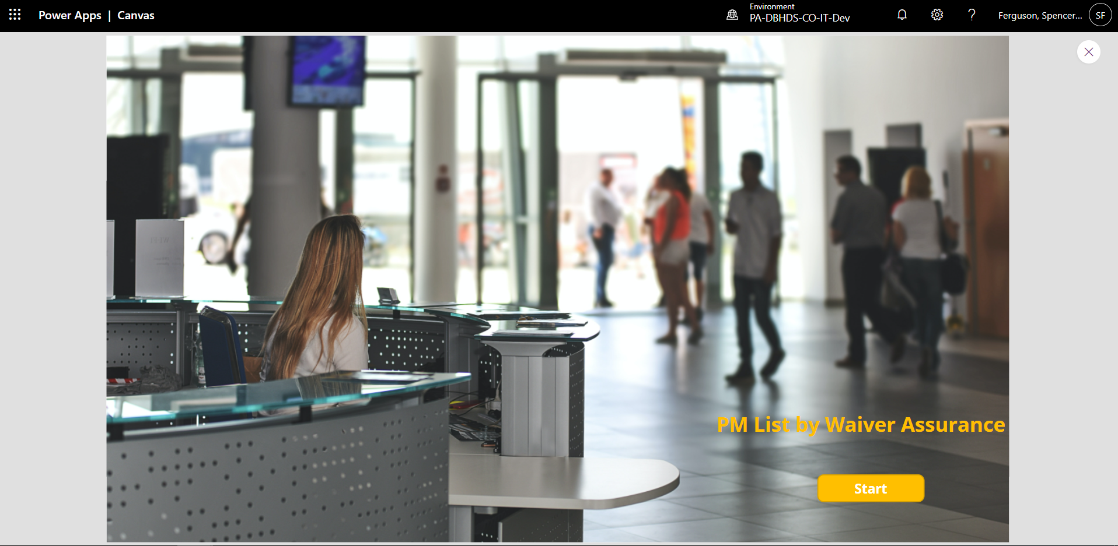
- Users of the App will click “Start” on the home page, and proceed to the main page of the App for selecting records (Performance Measures) to enter data.
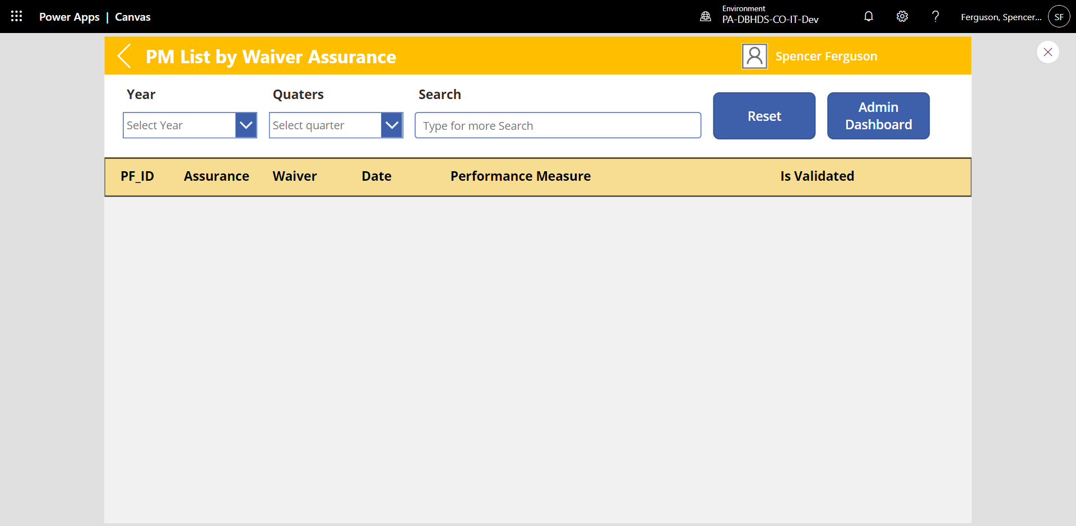

- By design, no records show when a user first accesses the app. A selection needs to be made in the “Year” and “Quarter” dropdowns. **It is important to note that only records users are responsible for entering against will show in the app. Once selections are made in the dropdowns, the user can see associated records for data entry.
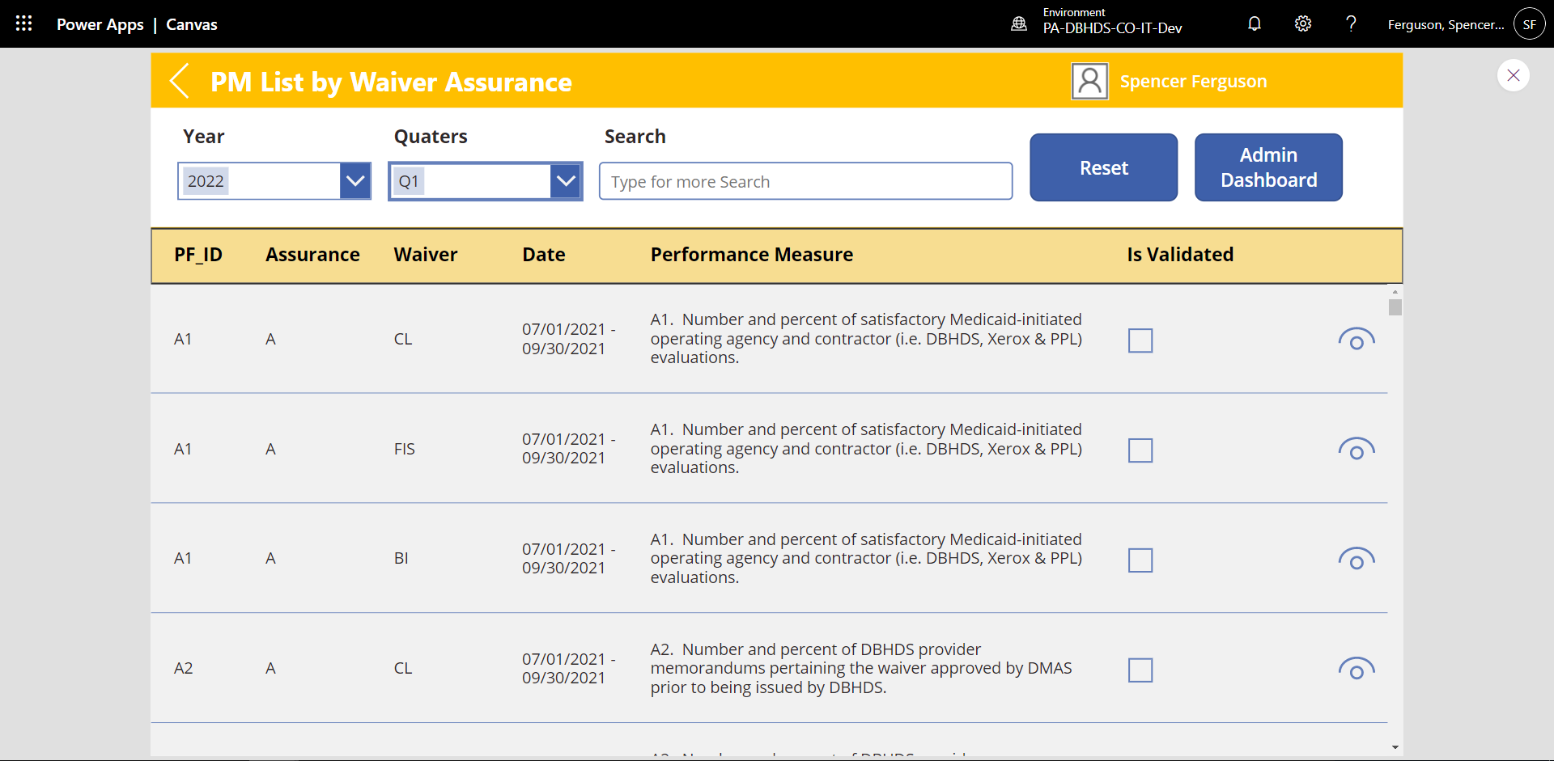

- At this stage, the user can click on the “View” icon at far right for the record of interest. The view icon looks like an eye.
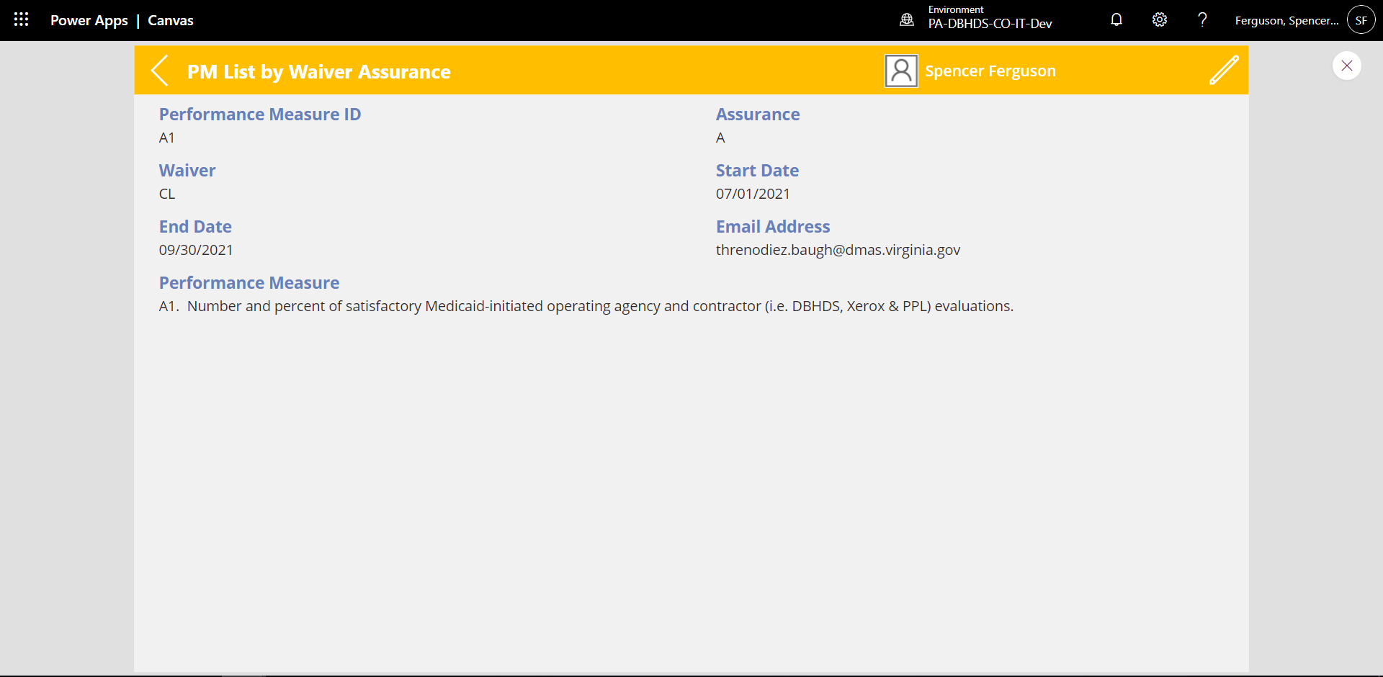
- Upon doing so, the record will appear and allow for data entry via the “Edit” icon at top right, which looks like a pencil.

- Next, data is entered into the available fields on the page. Notice that text narrative can be copied and pasted into the Notes, QMR Caps, Remediation, and CRT Training fields at the bottom.

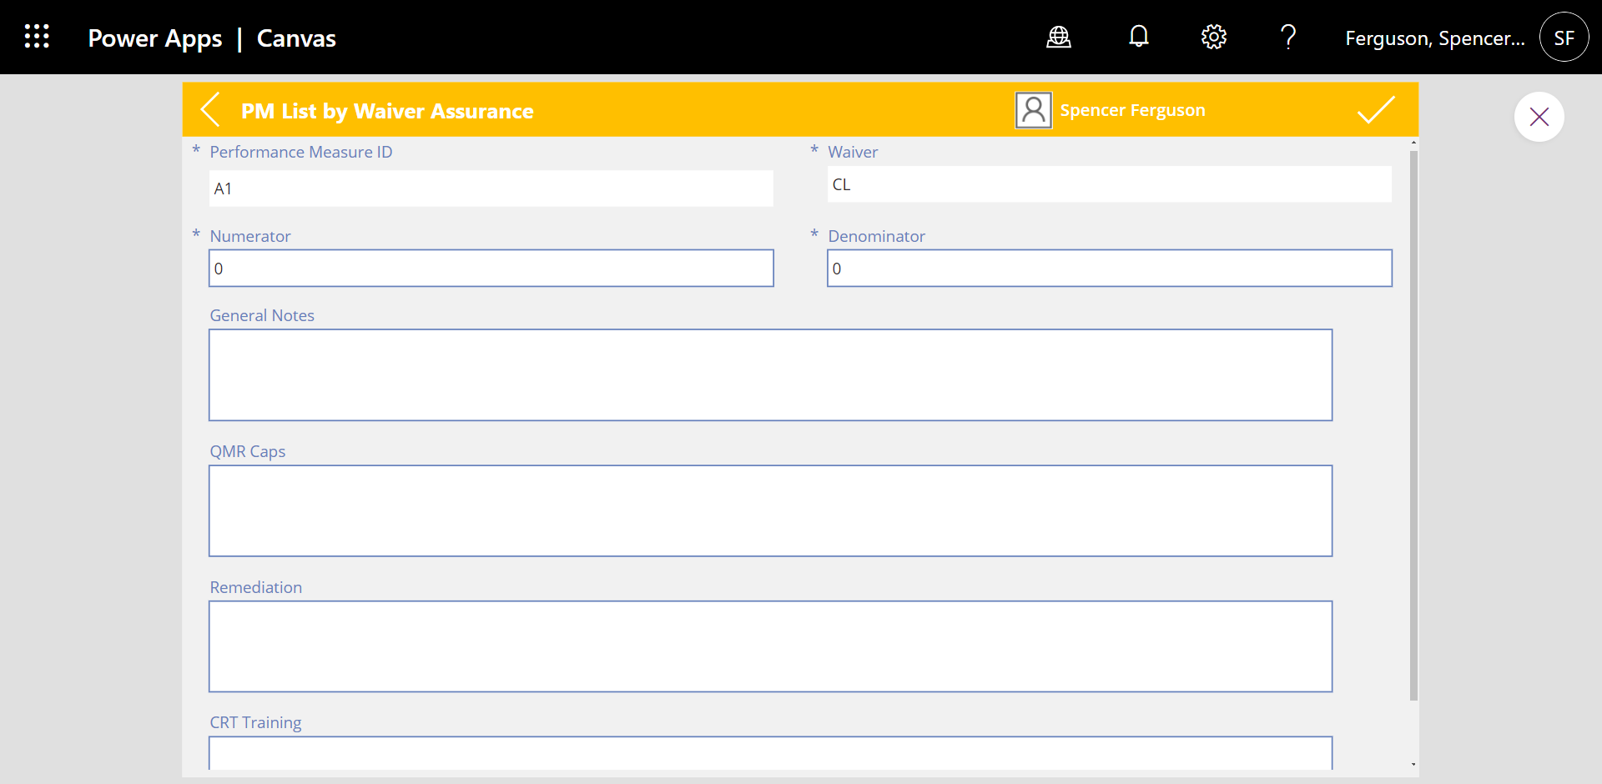

- Once the user is finished entering data for the PM, the “Check mark” icon at the top right can be selected. This action will save the data for later viewing. A success screen will appear upon saving.
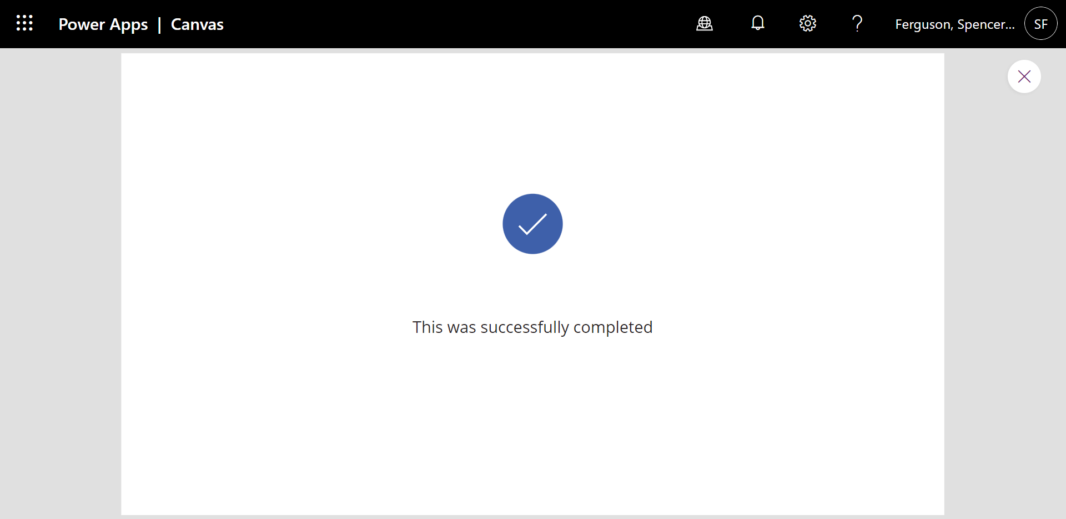
- Please note the data will be saved, but it can be modified until the deadline provided by the Program Admin.
- Next, the user will continue entering data for the quarterly PMs until all applicable information is entered and saved.

