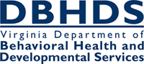
Human Rights CHRIS Changes
Individual (Select Individual) Tab
The SSN is now required. Note: If the individual does not have a SSN or the SSN is unknown, enter 999999999. This requirement will also apply to serious incident reports made to the Office of Licensing. The enhancement will assist the department in identifying duplicate entries and contribute to the development of a unique identifier.
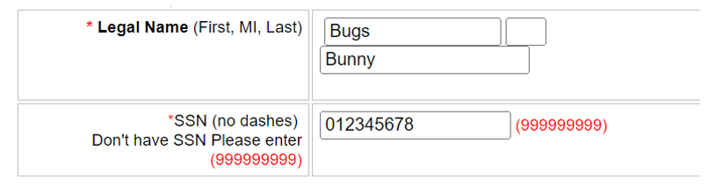

In the Demographics section of this tab, the Substitute Decision Maker field is now required. When “Yes” is selected, the “Name” and “Relationship to Individual” fields must be completed. This will assist the department in knowing when certain notifications and decisions intended for the Substitute Decision Maker are applicable.

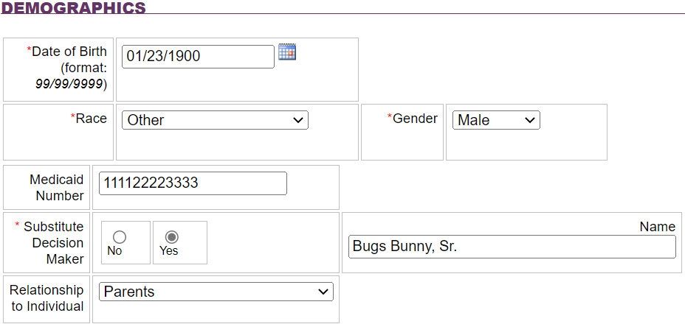

Allegation Tab
When entering the Location, the FIPS code will now automatically populate. This enhancement is intended to save time for the end-user as well as prevent end user error in selecting the wrong FIPS code.

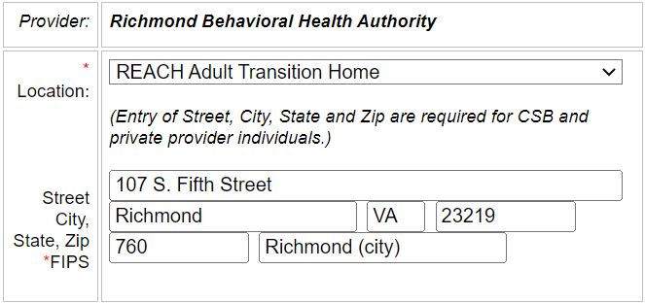

Types of abuse and neglect have been added and expanded to assist in identifying complaints involving abuse, neglect, and exploitation.
- Four new abuse types have been added – Psychological; Neglect: Missing Individual, Elopement, AWOL; Neglect: Medication Related; and Neglect: Failure to provide services necessary for health, safety and welfare. Multiple types of abuse may still be selected.
  - Psychological – individual is alleged to have experienced emotional harm that may be evidenced by changes in the individual’s behavior (i.e. becoming withdrawn, avoidance of specific people or situations)
  - Neglect: Medication Related - a mistake by the provider in administering medication to an individual and includes when any of the following occur: wrong medication is given to an individual, wrong dosage of a medication is given to an individual, the wrong method is used to give the medication to the individual and/or the medication is given to an individual at the wrong time or not at all.
  - Neglect: Missing/Elopement/AWOL refers to when an individual is not physically present when and where they should be and their absence cannot be accounted for or explained by their supervision need, and the individual has been determined to lack capacity or their capacity is currently in doubt. This option may be selected when it is not clear that the provider followed their internal policy regarding supervision and support at the time the individual left or was discovered to have left the program/service.
  - Neglect: Failure to provide nourishment, treatment, care, goods or services – failure to provide what is necessary for the individual’s health, safety and welfare in accordance with their identified needs (ISP) and the level of service, (i.e. failure to provide food, clothing, support or appropriate supervision). This option may be selected when the identified failure could be the result of inaction by one or more staff or possibly the result of a programmatic failure (i.e. inadequate policy or infrastructure).
- Seclusion and Restraint have been made their own type of abuse.

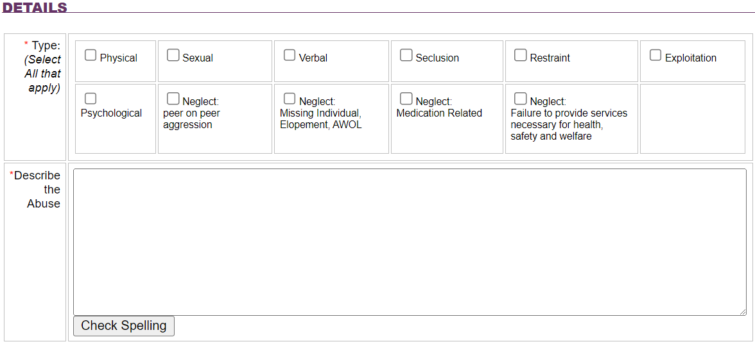
The “Print Abuse” or “Print Complaint” button allows the user to view the record prior to printing or saving.

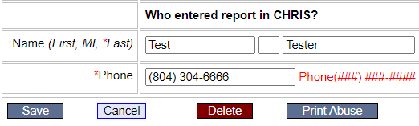

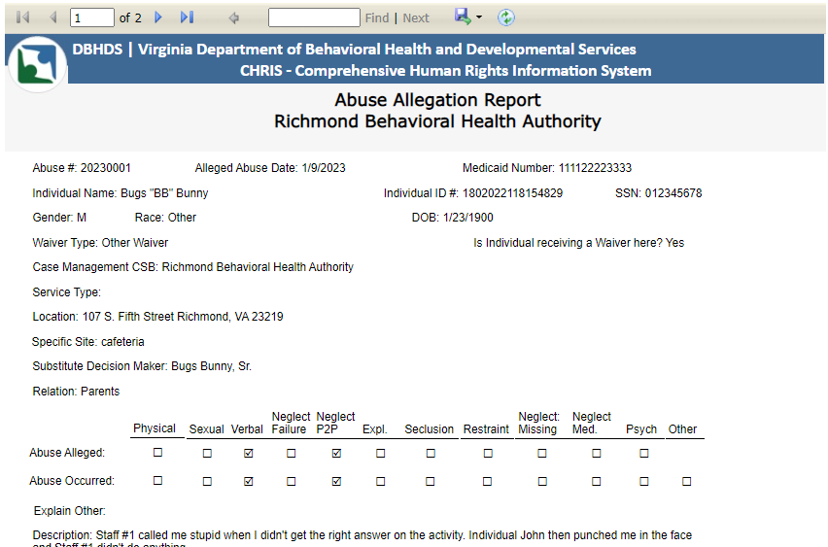

Notification Tab
Department of Health Professions notification has been added. This section is not required to save the record. The information should be entered when applicable, to ensure an accurate and complete CHRIS entry.

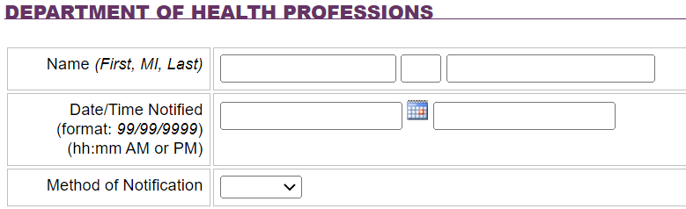

Investigation Tab
The Disposition section of this tab has been updated to reflect all the types of abuse and neglect on the Allegation tab.
Additionally, an “Other (Explain on below textbox)” category has been added. When this is checked, an explanation must be provided in the textbox. This box should be checked when a violation besides abuse, neglect or exploitation has been identified.
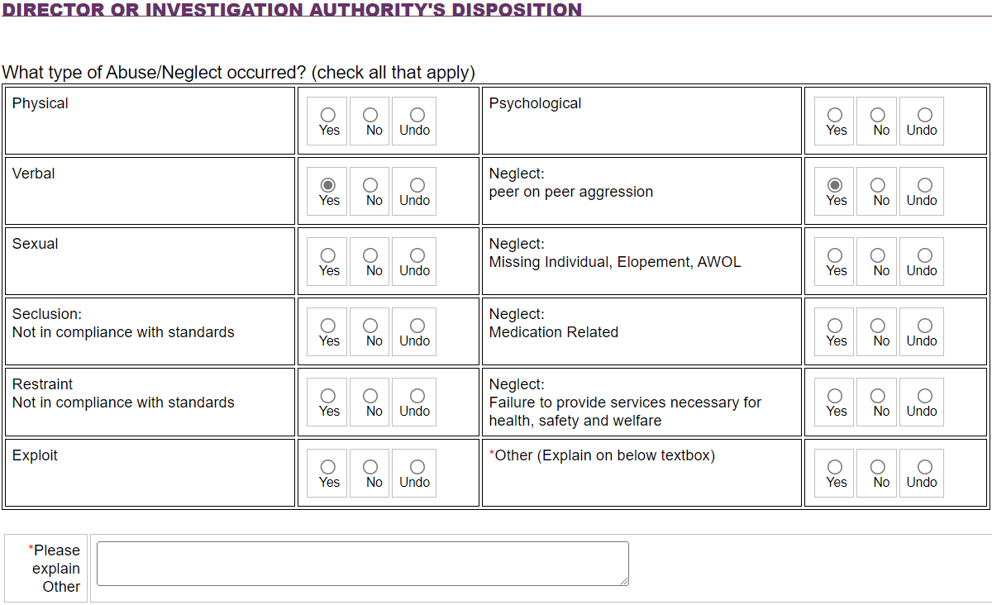

In the Rationale section, the “Other” checkbox has been revised to read, “Other (e.g., video footage).” As a reminder, this option should be checked, and the corresponding textbox completed to describe the evidence used to determine the disposition.
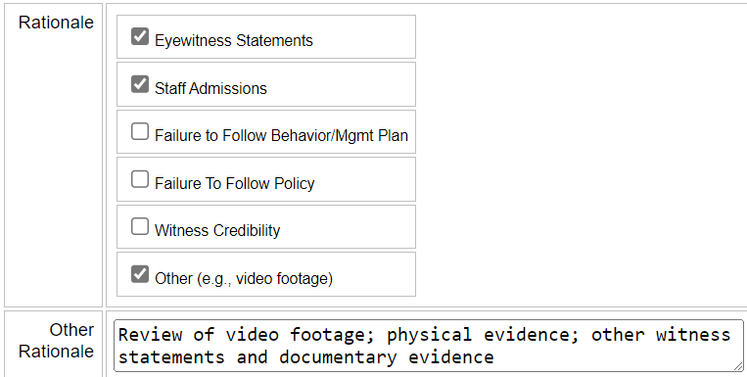

Reports
The Reports option in the left side Navigation bar allows the end user to view abuse, complaint, and other reports. This option can be accessed from any tab in CHRIS.

