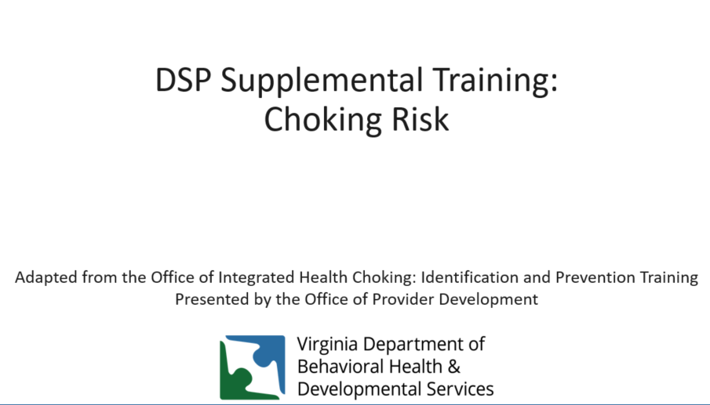

Welcome to the DSP supplemental training on identifying and responding to choking events. This training has been adapted from the Office of Integrated Health Choking: Identification and Prevention Training. This training supplements the content available at https://web.partnership.vcu.edu/DSP_orientation/index.html.

Learning Objectives:
Upon completion of this training, you will be able to:
-Define choking
-Review signs and symptoms of choking
-Identify chronic conditions which increase risk
-Identify foods known to increase risk of choking
-Identify types of medications known to increase risk of choking
-Identify signs and symptoms of someone who may be choking
-Identify health care professional who is able to assess swallowing
-Identify behaviors that may increase risk of choking
-Identify steps which can be taken to prepare for a choking emergency

Airway Obstruction/Choking Introduction: (Page 1, OIH Choking Health & Safety Alert 2020)
Choking (object in the airway) can be a partial or complete obstruction of the airway due to a foreign body (e.g. a bead, toy, etc.), whether intentional (pica) or unintentional (typically in childhood). Choking can also be a partial or complete obstruction of the airway due to food. Age or other chronic conditions can affect neurological and neuromuscular functioning, and put individuals at increased risk. An increased risk of choking has also been attributed to the consumption of alcohol, certain medications, dysphagia, tardive dyskinesia, poor dentition (loose, missing, or decaying teeth) and poor positioning. Some behaviors can also increase the risk of choking. The risk of choking is multiplied with each additional risk factor the individual has (Berzlanovich et al., 2005).

Increased risk of choking may also be related to:
-Alcohol consumption
-Certain medications
-Dysphagia: Dysphagia refers to difficulty swallowing foods or liquids, arising from the throat or esophagus, ranging from mild difficulty to complete and painful blockage.
-Tardive Dyskinesia: Tardive dyskinesia (TD) involves involuntary movements of the tongue, lips, face, trunk, and extremities that occur in patients treated with long-term psychiatric medications.
-Loose, missing, or decaying teeth
-Poor positioning
-Behavioral concerns
The risk of choking is multiplied with each additional risk factor (Berzlanovich et al., 2005).

Choking typically occurs while eating. The correct food path leads to the stomach where food is digested.
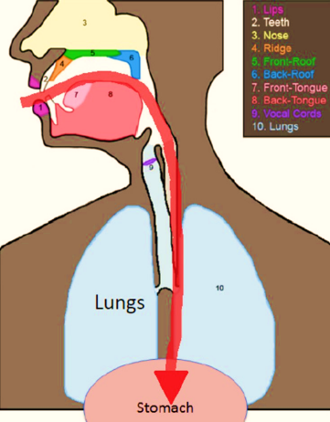

The incorrect food path leads to the lungs, resulting in either choking, if the airway is blocked by food, drink, or foreign objects, or aspiration if food, drink, or foreign objects are breathed into the lungs (“going down the wrong tube”). It might happen during choking, but aspiration can also be silent, meaning that there is no outward sign.
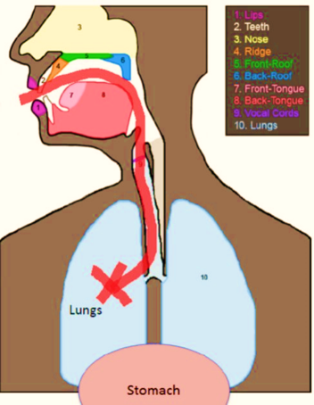

Some other factors that increase choking risk:
-A history of aspiration pneumonia.
-Gastroesophageal Reflux Disease (GERD) and or a history of GERD
-Parkinson’s
--Seizures
Alzheimer’s
-Cerebral Palsy
-Multiple Sclerosis
-Prader Willi Syndrome
-Dysphagia (difficulty swallowing)
-Down Syndrome
For more examples, see the OIH Choking Health & Safety Alert 2020 provided with this training- Factors/Conditions Which Increase Choking Risk (Page 3-4, OIH Choking Health & Safety Alert 2020)

A Diagnosis of Dysphagia Can Increase Choking Risk (Page 2, OIH Choking Health & Safety Alert 2020)
What is dysphagia? If an individual is diagnosed with dysphagia it means they have difficult or abnormal swallowing. It can also mean that it hurts to swallow, and/or the swallowing process is unsafe for an individual and can pose a choking and/or an aspiration risk. Watch for the following signs and symptoms of dysphagia in individuals:
-Frequent episodes of gagging, coughing or choking during or after eating/drinking.
-Difficulty managing saliva (drooling).
-Difficulty closing lips.
-Wet vocal quality during or after eating/drinking.
-Runny nose during or after eating/drinking.
-Watery eyes during or after eating/drinking.
-Frequent bouts with pneumonia.
-Frequent upper respiratory infections.
-Swallowing food whole in order to “get it down” fast without anyone noticing a problem.
-Eating/drinking quickly.
-Extra effort or time to chew and/or swallow.
-Pain with swallowing.
-Pocketing food or liquid in cheeks.
-Loss of food or liquid.
-Frequent vomiting.
-Weight loss or dehydration from inadequate intake.
-Weak facial muscles.
-Difficulty chewing (Bryant-Waugh, et al., 2019; Lindvall, et al., 2017; Thomas & Eddy, 2018).

If an individual you care for has any of the symptoms listed above, they may have dysphagia and may be at an increased risk for choking and aspiration. Please contact the individual’s PCP at your earliest convenience to explain your concern. A referral to a speech language pathologist (SLP) for further assessment may be needed. Please be sure to take a list of all of the individual’s medications to their appointment. Certain medications can increase choking risk.

Any DD Diagnosis Can Increase Choking Risk (Page 5, OIH Choking Health & Safety Alert 2020)
Among individuals with DD, research suggests that individuals with Down syndrome (Thacker et al., 2008) and those with Prader Willi Syndrome are at exceptionally high risk for choking, when compared to other genetic disorders (Stevenson et al., 2007). Down Syndrome is a condition in which a child is born with an extra copy of their 21st chromosome — hence its other name, trisomy 21. This causes physical and mental developmental delays and disabilities. Individuals with Down Syndrome lack tongue control and frequently have an underdeveloped jaw, which can lead to impaired chewing, and poor ability to use their tongue thrust to assist during swallowing (Thacker et al., 2008).
Prader Willi Syndrome (PWS) isa complex genetic condition that affects many parts of the body. In infancy, this condition is characterized by weak muscle tone (hypotonia), feeding difficulties, poor growth, and delayed development. Beginning in childhood, affected individuals develop an insatiable appetite, which leads to chronic overeating (hyperphagia) and obesity.
Individuals with Prader Willi Syndrome (PWS) are at an increased risk for choking (Stevenson et al., 2007) due to poor oral/motor coordination, poor gag reflex, hypotonia, polyphagia or hyperphagia (abnormally strong sensation of hunger or desire to eat), decreased mastication and voracious eating habits ((Stevenson et al., 2007; Thacker et al., 2008). Researchers recommend implementation of preventive measures and education for family caregivers and group home care providers for all individuals diagnosed with PWS including the Heimlich maneuver, eyes-on, supervised meals, and food preparation and diet modification recommendations via an assessment with an SLP, to avoid high risk choking textures and foods (Stevenson et al., 2007).

Some medications may increase choking risk:
-antipsychotic drugs
-medications that affect throat muscles (e.g. Cogentin)
-antihistamines and other medications that cause dry mouth
-medications affecting the central nervous system (e.g. Tegretol)
-medications that linger in the throat (e.g. Tetracycline)
-anti-cancer drugs or high dose steroids
For more examples, see the OIH Choking Health & Safety Alert 2020 provided with this training.
Be sure to talk with the physician, pharmacist, and/or read side effect information to evaluate each medication for associated risk.

Structural Abnormalities can be Congenital or Acquired and may increase risk of choking.
Cleft lip and palate are examples of congenital structural abnormality, as can tongue dysfunction and high palate.
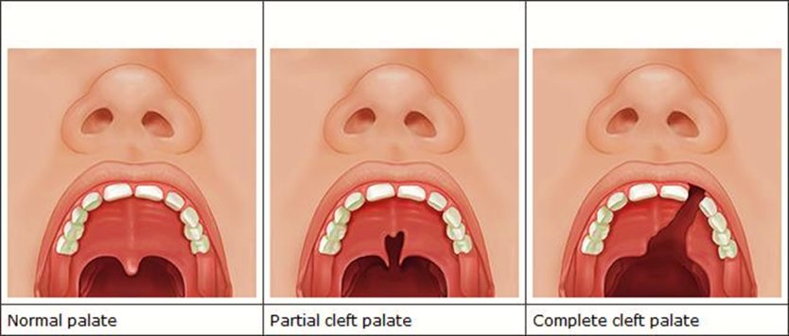
Structural, functional and neuromuscular abnormalities, including high palate occur in numerous congenital syndromes associated with intellectual disability and would place the individual at a higher risk of choking. Some of these are: Fragile X, Marfan syndrome (MFS, and Van der Woude syndrome. For more examples, see the OIH Choking Health & Safety Alert 2020 provided with this training.
Tongue dysfunction results in:
-Impaired chewing
-Impaired formation of a mass of chewed food ready to swallow
-Impaired transport of the chewed food
-Excessive retention of food in oral cavity
Tongue dysfunction increases choking risk because food can become dislodged when the individual reclines and can cause an airway obstruction.
Tongue dysfunction occurs in numerous congenital syndromes.
A high (but closed) palate can also result in an increased choking risk. Why?
Because food can be trapped in a high palate while eating, but fall down into the mouth when the individual reclines.
A high arched palate is a symptom of numerous congenital syndromes.

Missing Teeth (Poor Dentition), No Teeth (Edentulous), Loose Teeth, or Decaying Teeth Can Increase the Risk of Choking (Page 8, OIH Choking Health & Safety Alert 2020)
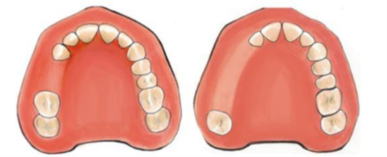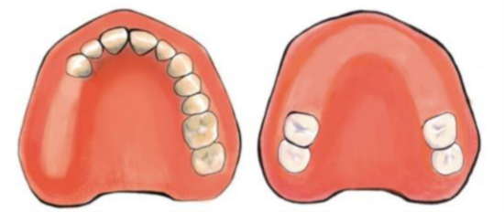
Loss of any teeth reduces masticatory performance. This can result in a mass of chewed food that may be too large to safely swallow. If an individual you care for has any loose, decayed or missing teeth, they are at an increased risk for choking (airway obstruction). Please contact the individual’s PCP at your earliest convenience, to explain your concern. A referral to a speech language pathologist (SLP) for further assessment may be needed. Please be sure to take a list of all of the individual’s medications to their appointment. As mentioned previously, certain medications can increase choking risk.
Chewing (mastication) falls under the SLP assessment area of “oral preparatory stage of swallowing”. A speech language pathologist can assess someone with a chewing (mastication) disorder. The mouth and teeth begin the digestion process by breaking food into small pieces that can be formed into a bolus, which can then be swallowed. Saliva softens food, teeth grind food and the tongue manipulates food into a bolus. If an individual has difficulty with any part of this process, they may be at higher risk of choking and need to have an assessment completed by a Speech Language Pathologist or SLP.

Diagnosed Feeding or Eating Disorders Can Increase Choking Risk (Page 6, OIH Choking Health & Safety Alert 2020)
Some individuals may have sensory issues relating to food. This difficulty can be due to any of the reasons listed in this document or it may be due to a diagnosed feeding or eating disorder. Avoidant Restrictive Food Intake Disorder (ARFID), Pica, and Rumination Disorder (RD) are all characterized by avoidant and restrictive eating, which can lead to: a failure to meet nutritional and/or energy requirements; significant weight loss; or failure to gain expected weight; dependence on oral nutritional supplements or enteral feeding; nutritional deficiencies; and/or difficulties with psychosocial functioning. Individuals with ARFID may also restrict or avoid food intake for reasons that relate to the sensory aspects of food or eating (e.g., taste, smell, texture); lack of interest in food or eating; or because of the feared negative consequences (e.g. choking, vomiting) associated with eating (APA, 2013; Bryant-Waugh, et al., 2019; Lindvall, et al., 2017; Thomas & Eddy, 2018).
Avoidant Restrictive Food Intake Disorder (ARFID) ARFID is similar to anorexia in that both disorders involve limitations in the amount and/or types of food consumed, but unlike anorexia, ARFID does not involve any distress about body shape or size, or fears of fatness.
Pica Pica is an eating disorder that involves eating items that are not typically thought of as food and that do not contain significant nutritional value, such as hair, dirt, and paint chips.
Rumination Disorder (RD) Rumination disorder involves the regular regurgitation of food that occurs for at least one month. Regurgitated food may be re-chewed, re-swallowed, or spit out. Typically, when someone regurgitates their food, they do not appear to be making an effort, nor do they appear to be stressed, upset, or disgusted.

Certain Behaviors can Increase Risk of Choking (Page 8, OIH Choking Health & Safety Alert 2020)
Behaviors which increase the risk of choking:
-Placing too much food or medication in one's mouth.
-Not chewing food well enough prior to swallowing.
-Putting large portions of food in one's mouth.
-Eating too fast.
-Drinking too fast.
-Inattention while eating.
-Food stealing - resulting in obtaining non-prescribed/inappropriate diet, etc.
-Swallowing food whole.
-Isolating behaviors.
If an individual has any of the behaviors mentioned in this document, they are at an increased risk for choking (airway obstruction). Please contact the individual’s PCP at your earliest convenience, to explain your concern. A referral to a speech language pathologist (SLP) and/or a Board Certified Behavior Analyst (BCBA) may be needed. Please be sure to take a list of all of the individual’s medications to their appointment. As mentioned previously, certain medications can increase choking risk.
Some individuals may feel embarrassment when they have difficulty eating, and may move away from others or may want to eat their meals in their bedrooms. This type of behavior places those individuals at an increased risk because they are less likely to be near people who can help. When food is served, be alert to those who may choose to leave, and check on them to ensure they are not in need of assistance.
Strategies for choking prevention should include caregiver education on eating habits of individuals (stuffing food, etc.) that can increase their risk of choking. Caregivers who observe any of the behaviors in the aforementioned list, should notify their direct supervisor immediately and/or follow their agency’s policy for notification. The individual’s PCP should be notified that a particular risky behavior has been observed, and a protocol for observation (at a minimum), should be developed with the help of a nurse, and/or an SLP, and/or a physician.
-Learn about high risk eating habits (stuffing food, isolation, etc.) and make sure all staff members are aware of what to watch for.
-If high risk eating behaviors are observed, instruct staff to notify their direct supervisor immediately and document the incident.
-The individual’s PCP should be notified as soon as possible, if any high risk eating behaviors are observed.
If the choking incident is related to the individual’s behavior’s (in any way), a referral to a specialist in behaviors, such as a Board Certified Behavior Analyst (BCBA) or a Positive Behavioral Supports Facilitator (PBSF) may be needed. A BCBA is a licensed healthcare professional who studies the behavior of children and adults and has experience and training in the development and execution of plans to improve or change a particular behavior, or behaviors. “Positive behavior support is an applied science that uses educational methods to expand an individual’s behavior repertoire and systems change methods to redesign an individual’s living environment to first enhance the individual’s quality of life and, second, to minimize his or her problem behavior” (Carr, et al., 2002, p. 4) http://personcenteredpractices.org/launch_vpbs.html

Where to get help:
All those at an increased risk for choking and/or aspiration for any condition mentioned on the previous slides (or any other which puts them at higher risk), should be evaluated by a healthcare professional as soon as possible.
Schedule an appointment with the individual’s primary care physician (PCP) at your earliest convenience for a referral to the appropriate specialist for an assessment. (Be sure to get a script for the assessment from the individual’s PCP.)
The individual’s PCP will know which specialist to best assess the individual’s particular condition and or their choking risk.
If an individual you care for has any of the health conditions mentioned, they may be at an increased risk for choking (airway obstruction). Please contact the individual’s PCP at your earliest convenience to explain your concern. A referral to a speech language pathologist (SLP) for further assessment may be needed. Please be sure to take a list of all of the individual’s medications to the appointment. Certain medications can increase choking risk.
Healthcare professionals who can assess issues with choking and or swallowing are:
-Speech Language Pathologists (SLPs).
-Otolaryngologists (aka Ear, Nose & Throat Doctor or ENT).
-Gastroenterologists (they specialize in conditions affecting the entire digestive system).
A meal time and or eating protocol including observations (at a minimum), should be developed with the assistance of a healthcare professional. Please follow all physician-ordered protocols.
If you need additional guidance on eating protocols, please ask the individual’s PCP for a referral for assessment with a Speech and Language Pathologist, commonly known as an SLP.

Some techniques that may be advised by healthcare professionals in order to prevent choking:
Maintaining a neutral head position allows the airway to remain closed while swallowing. While assisting an individual to drink or eat, hold cups and utensils level with the individual’s mouth.
Holding a cup too high will cause flexion of the neck, which opens the airway putting an individual at greater risk of choking and aspiration.
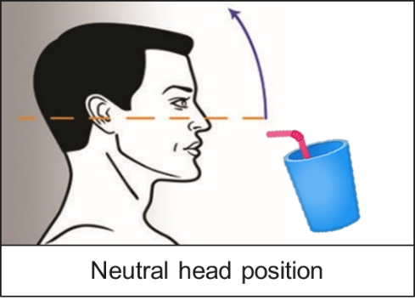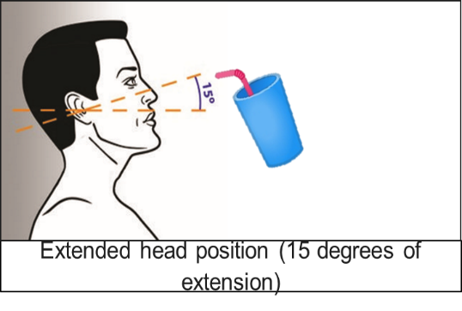
For some people, treatment may involve avoiding certain foods. Others may not be able to drink thin liquids and may need to have special thickeners added to them prior to consumption. Other people may have to avoid hot or cold foods or drinks, which can trigger choking incidents in some people. If the individual is diagnosed with dysphagia, caregivers will be instructed on the protocols and precautions needed to prevent aspiration. This might include diet modification or thickening of liquids, positioning, protocols for eating and drinking, etc. A referral to a dietician or nutritionist may be recommended. PCP orders for diet modification may also be needed.
The individual’s PCP, a nurse, a dietician and/or a nutritionist can help you develop a well-thought out protocol for eating and drinking for someone who has a high choking risk. Do not attempt to formulate protocols without a healthcare professional’s input and written order affirming approval. (The SLP may write the protocols, and the PCP will sign them, in some situations.) Please make sure all caregivers in all settings the individual visits on a regular basis are aware of these changes and protocols. Make sure all changes, protocols, etc. are included in the individual’s ISP (or IEP, if the individual is still in school), and update them as needed.

Emergency Preparedness to Lower the Risk of Choking Fatalities
Everyone is at risk for choking. Individuals with DD are at higher risk for choking. Caregivers should learn the Heimlich maneuver and CPR in a certified first-aid training course and practice putting both into action during your emergency preparedness training drills. The use of caregiver drills or mock emergencies in order to reinforce emergency protocols for choking is a good idea. Practicing an emergency protocol, and allowing direct caregivers to have a chance to ask questions, can build confidence and improve technique. Repetition of any activity increases memory of any skill (Popov & Reder, 2017) and gives participants a chance to build their skills. Having all staff trained in the Heimlich maneuver, CPR and First Aid represents best practice. It is also important to keep skill requirements current with refresher courses.
In addition, the use of well-displayed posters with clear instructions on the steps a caregiver should follow (for both the Heimlich maneuver and CPR) is a good idea. A poster can serve as a visual reminder of the steps needed, (e.g. the placement of hands, the sequence, the number of repetitions, etc.), and can help calm caregivers’ nerves when, or if, they begin to panic and cannot remember what to do, when an individual is choking.

What not to do:
-DO NOT rush mealtimes
-DO NOT plan other activities during mealtimes
-DO NOT permit eating or drinking while the individual is lying down
-DO NOT give foods or liquids that a particular individual has difficulty swallowing
-DO NOT assist individuals to bed, for at least 30 minutes after eating or drinking
-DO NOT give foods or liquids restricted by an individual’s health care provider
-DO NOT start mealtime if the individual is too lethargic, angry, anxious, or if they cannot sit still
-DO NOT let an individual finish eating a particular food item, if that food item has just caused the individual to choke

Make Sure Staff Are Aware of Foods Identified as "High Risk" for Choking (Page 13, OIH Choking Health & Safety Alert 2020)
Be sure to include high risk foods that are specific to the person in their individualized protocols.
-Corn
-Grapes
-Bananas
-Hard nuts
Marshmallows
-Peanut butter (any kind)
-Chicken on the bone
-Candy with large nuts
-Hotdogs served whole
-Whole, hard fruits like apples or pears
-Peanut butter sandwiches on soft bread
-Thick chewy bread, e.g. white bread, bagels, pizza, etc.
-Whole, raw vegetables served in large bite-sized pieces
-Dry meats such as ground beef served without sauce, gravy
-Dry, crumbly foods such as cornbread or rice served without butter, jelly, sauce, etc.
-Incorrect diet texture - liquids or food items not prepared in accordance with a prescribed diet
-Eating something with two or more diet textures, especially anything with a thin liquid in addition to a solid component, such as cereal and milk (Sidell, et al., 2013)

Protocols for lowering the risk of choking:
It is essential to consult the individual’s PCP and SLP to ensure a person centered support plan and or choking protocol meets their specific needs. All person centered support plans and/or protocols must meet human rights guidelines and require approval with signature from a healthcare professional (12VAC35-115-100).
Possible protocols:
-Protocols for Pica precautions.
-Protocols for hands-on, staff-assisted eating.
-Protocols for direct visual supervision when the individual is consuming food.
-Protocols for assisted eating or drinking techniques, using adaptive equipment.
--Protocols for implementing physician orders for prescribed diets and or for thickening foods.
Protocols limiting access to food impact an individual’s human rights which requires approval from the local human rights counsel (LHRC) prior to implementation.

Ways to support:
-The universal sign for choking is both hands clutched to the throat.
-Demonstrate the Universal Choking Sign to individuals and teach individuals (who are cognitively and physically able) how to do it themselves.
-Have them demonstrate it to you at routine intervals to make sure they remember how to do it, and when they should use it (i.e. when they are choking).
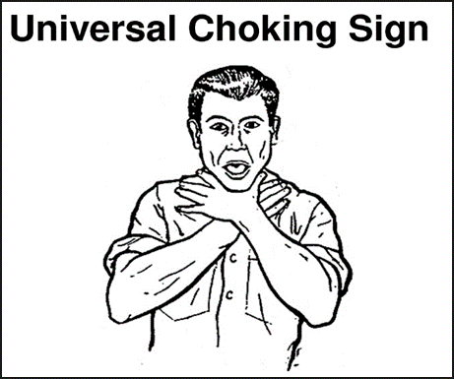
Some people who choke can still breathe.
Look for these Symptoms:
-Look of fear or panic
-Reddish face
-Grabbing throat
-Drooling
-Forceful coughing

Some people who choke can NOT breathe.
Look for these Symptoms:
-Can not speak
-Grayish or pale face
-Bluish lips
-Grabbing throat
-High-pitched noise or no noise

The companion document for use with this training is available online at the link below. Be certain to review and keep in a location for easy reference: https://dbhds.virginia.gov/assets/doc/OIH/choking-health-safety-alert.pdf
Office of Integrated Health (OIH) at DBHDS: http://www.dbhds.virginia.gov/office-of-integrated-health
Newsletters & Safety Alerts Archive: http://www.dbhds.virginia.gov/office-of-integrated-health/safety-alerts-archive
If you have a technical assistance question, please email the Registered Nurse Care Consultant (RNCC) Team at: communitynursing@dbhds.virginia.gov
Office of Provider Development https://dbhds.virginia.gov/developmental-services/provider-development

Resources:
American Red Cross (2011). First aid conscious choking poster. file:///C:/Users/dha92624/Downloads/first-aid-consciouschokingposter-en.pdf
American Red Cross (n.d.). How do you care for a conscious choking victim? https://www.youtube.com/watch?v=UVNxP7K2ATE
American College of Emergency Physicians. Choking (Heimlich maneuver). https://www.emergencyphysicians.org/article/know-when-to-go/choking--heimlich-manuever
American Academy of Pediatrics. (2011). Choking Prevention and First Aid for Infants and Children https://www.laborposters.org/first-aid/1805-choking-cpr-for-children-or-infants-poster.htm
American Red Cross (2010). CPR/AED for professional rescuers and health care providers. https://www.redcross.org/content/dam/redcross/atg/PHSS_UX_Content/CPRO_Handbook.pdf
Resuscitate! CPR AED & Choking App Stone Meadow Development LLC https://apps.apple.com/us/app/resuscitate-cpr-aed-choking/id363393502
National Safety Council’s Emergency Response App It provides a list of abbreviations and memory aids, as well as an illustrated summary of treatment steps for various illnesses and injuries. https://play.google.com/store/apps/details?id=com.nsc.hybrid&hl=en_US
If you have any questions about the information contained in this Health & Safety Alert, please email your question to the Office of Integrated Health’s nursing team at: communitynursing@dbhds.virginia.gov
What to do when a Wheelchair User is choking: https://www.aid-training.co.uk/news/what-to-do-when-a-wheelchair-user-is-choking
The ARC handout on Choking an Obesity, Choking in a Wheelchair: https://hrstonline.com/demo/elearning/live/choking/choking-part-2/Choking%20with%20Morbid%20Obesity%20Protocol.pdf
How to deal with a choking wheelchair user YouTube video: https://www.youtube.com/watch?v=1L1dR9qUN0E
A.I.D Training & Operations Ltd (2015). What to do when a wheelchair user is choking. https://www.aid-training.co.uk/news/what-to-do-when-a-wheelchair-user-is-choking
American Academy of Pediatrics. (2011). Choking Prevention and First Aid for Infants and Children https://www.laborposters.org/first-aid/1805-choking-cpr-for-children-or-infants-poster.htm
American College of Emergency Physicians. Choking (Heimlich maneuver). https://www.emergencyphysicians.org/article/know-when-to-go/choking--heimlich-manuever
American Red Cross (2010). CPR/AED for professional rescuers and health care providers. https://www.redcross.org/content/dam/redcross/atg/PHSS_UX_Content/CPRO_Handbook.pdf
American Red Cross (2011). Adult first aid/CPR/AED: Ready reference. Retrieved from https://www.redcross.org/content/dam/redcross/atg/PDF_s/Health___Safety_Services/Trainin g/Adult_ready_reference.pdf
American Speech, Language, Hearing Association (n.d.). Adult dysphagia. https://www.asha.org/PRPSpecificTopic.aspx?folderid=8589942550&section=References
Balzer, K. M. (2000). Drug-induced dysphagia. International Journal of MS Care, 2(1), 40-50. Retrieved from http://ijmsc.org/doi/abs/10.7224/1537-2073-2.1.40?code=cmsc-site
Berzlanovich, A. M., Fazeny-Dörner, B., Waldhoer, T., Fasching, P., & Keil, W. (2005). Foreign body asphyxia: a preventable cause of death in the elderly. American journal of preventive medicine, 28(1), 65-69. https://www.sciencedirect.com/science/article/abs/pii/S0749379704000777?via%3Dihub
Bryant-Waugh, R., Micali, N., Cooke, L., Lawson, E. A., Eddy, K. T., & Thomas, J. J. (2019). Development of the Pica, ARFID, and Rumination Disorder Interview, a multi-informant, semi-structured interview of feeding disorders across the lifespan: A pilot study for ages 10-22. The International journal of eating disorders, 52(4), 378–387. https://doi.org/10.1002/eat.22958
Carl, L. L., & Johnson, P. R. (2006). Drugs and dysphagia: How medications can affect eating and swallowing. Austin, Tex: Pro-Ed.
Lindvall Dahlgren, C., Wisting, L., & Rø, Ø. (2017). Feeding and eating disorders in the DSM-5 era: a systematic review of prevalence rates in non-clinical male and female samples. Journal of eating disorders, 5, 56. https://doi.org/10.1186/s40337-017-0186-7
Lu, Q. F., Ma, Q., Rithwan, S. M. S., Ng, H. C., Lee, S. L., Lee, K. M., ... & Xie, H. (2017). Risk factors and nursing strategies to manage choking in adults with mental illness: a systematic review protocol. JBI Database of Systematic Reviews and Implementation Reports, 15(8), 1998-2003. https://journals.lww.com/jbisrir/Fulltext/2017/08000/Risk_factors_and_nursing_strategies_to_manage.5.aspx
Lumsden, A. J. & Cooper, J. G. (2017). The choking hazard of grapes: a plea for awareness. Archives of Disease in Childhood, 102, p. 473-474. Retrieved from https://adc.bmj.com/content/archdischild/102/5/473.full.pdf
Manduchi, B., Walshe, M., Burke, É., Carroll, R., McCallion, P., & McCarron, M. (2020). Prevalence and risk factors of choking in older adults with intellectual disability: Results from a national cross-sectional study. Journal of Intellectual & Developmental Disability, 1-12. https://doi.org/10.3109/13668250.2020.1763278
Martin-Harris, B., Brodsky, M. B., Michel, Y., Ford, C. L., Walters, B., & Heffner, J. (2005). Breathing and swallowing dynamics across the adult lifespan. Archives of Otolaryngology–Head & Neck Surgery, 131, 762–770.
M. B., Michel, Y., Ford, C. L., Walters, B., & Heffner, J. (2005). Breathing and swallowing dynamics across the adult lifespan. Archives of Otolaryngology–Head & Neck Surgery, 131, 762–770.
Mayo Clinic (2017). Choking: First aid. https://www.mayoclinic.org/first-aid/first-aid-choking/basics/art- 20056637#:~:text=Deliver%20five%20separate%20back%20blows,until%20the%20blockage%20is%20dislodged.
National Institute of Deafness and other Communication Disorders (NIDCD), National Institutes of Health (NIH) (2017). Dysphagia. https://www.nidcd.nih.gov/health/dysphagia#2
National Safety Council (2017). National Safety Council: Injury facts, 2017 edition. Retrieved from http://viewer.zmags.com/publication/20020222#/20020222/1
National Safety Council (2018). Choking prevention and rescue tips: Thousands of people die from choking every year. https://www.nsc.org/home-safety/safetytopics/choking-suffocation
National Safety Council (2020). EMR Guide. https://play.google.com/store/apps/details?id=com.nsc.hybrid&hl=en_US
Popov, V., & Reder, L. M. (2017). Repetition improves memory by strengthening existing traces: Evidence from paired-associate learning under midazolam. In CogSci. http://venpopov.com/papers/popov-reder-midazolam-cogsci2017.pdf
Sheppard, J. J., Malandraki, G. A., Pifer, P., Cuff, J., Troche, M., Hemsley, B., ... & Hochman, R. (2017). Validation of the choking risk assessment and pneumonia risk assessment for adults with intellectual and developmental disability (IDD). Research in developmental disabilities, 69, 61-76. https://doi.org/10.1016/j.ridd.2017.07.016
Sidell, D. R., Kim, I. A., Coker, T. R., Moreno, C., & Shapiro, N. L. (2013). Food choking hazards in children. International journal of pediatric otorhinolaryngology, 77(12), 1940-1946. https://doi.org/10.1016/j.ijporl.2013.09.005
Stevenson, D. A., Heinemann, J., Angulo, M., Butler, M. G., Loker, J., Rupe, N., Kendell, P., Clericuzio, C. L., & Scheimann, A. O. (2007). Deaths due to choking in Prader-Willi syndrome. American journal of medical genetics. Part A, 143A(5), 484–487. https://doi.org/10.1002/ajmg.a.31502
Thacker, A., Abdelnoor, A., Anderson, C., White, S., & Hollins, S. (2008). Indicators of choking risk in adults with learning disabilities: a questionnaire survey and interview study. Disability and rehabilitation, 30(15), 1131-1138. http://ergotherapeutedordogne.fr/wp-content/uploads/2018/01/5-indicators-of-choking-risk-in-adults-with-learning-disabilities.pdf
Tippett, D. (2020). Treatments tests and therapies: Dysphagia: What happens during a bedside swallow exam. https://www.hopkinsmedicine.org/health/treatment-tests-and-therapies/dysphagia- what-happens-during-a-bedside-swallow-exam
U.S. National Library of Medicine, Medline Plus (2018, Aug). Choking - adult or child over 1 year. Retrieved from https://medlineplus.gov/ency/article/000049.htm

