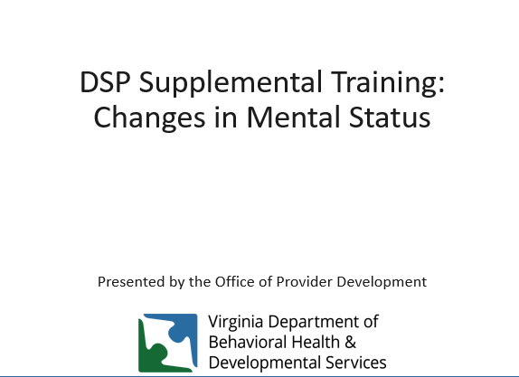
Welcome to the DSP supplemental training on identifying and responding to changes in mental status. This training supplements the content available at https://web.partnership.vcu.edu/DSP_orientation/index.html.

A change in mental status can refer to any changes in brain function resulting in…
- Confusion
-Memory Loss
-Loss of alertness
-Unusual thinking
-Poor judgement
-Emotional changes
-Behavioral changes
-Personality changes
There are many possible reasons a person experiences a change in mental status – some examples include:
-Infection
-Fever
-Medications
-Low blood sugar
-Stroke
-Liver failure
-Alcohol or drug use
-Consuming toxic substances
-Dementia
-Lack of oxygen (Anoxia)
-Brain injury
-Concussion
https://www.medicinenet.com/altered_mental_status/symptoms.htm

Recognizing change
What’s important is recognizing that a change has occurred and seeking medical assessment and care as soon as possible.
If the person’s health and safety is at risk contact 911 immediately.
You might notice some changes in how a person speaks or acts that could indicate calling a medical professional is needed.
For example, behavioral changes, walking pattern changes, changes in oral or hand motor control could indicate a need to seek medical attention.
A person could….
-Forget what day it is
-Lose attention more easily
-Forget the names of things or people they know
-Repeat a question again shortly after answered
-Begin stumbling or falling
-Start drooling or have trouble swallowing

Are there changes in:
-Physical function: How the individual moves or physically performs tasks?
-Memory: Remembering names, recent events or keeping up daily schedules? New confusion?
-Mood: New sadness, tearfulness, giddiness?
-Behavior: Increased agitation, hostility, anger, or acting out?
-Overall Health: What looks different compared to baseline?

Baseline
Baseline is defined as “a minimum or starting point used for comparisons.” In relation to mental status, it refers to how a person typically is prior to experiencing changes. It refers to the beginning measurement of behavior. By knowing what is ‘typical” you can help identify when changes in their mental status or baseline occur, without baseline data, it’s difficult to recognize changes. By talking to the individual, talking to those who know the individual and observation of the individual it can be helpful when changes occur to have an understanding of their baseline.
Think about what baseline means for the person?
What is their typical mood on most days? Has this changed?
What is their typical sleeping pattern on most nights? Has this changed?
What is their typical communication style and pattern? Has this changed?
What is their typical activity level? Has this changed?

Changes can be sudden or gradual:
-Sudden changes require an immediate response.
-Gradual changes can be discovered by making a list of what a person could do in past years and comparing it with what they can do now.
Asking those who know the person well if changes are apparent is an important way to identify gradual changes.
It can be difficult to recognize mental status changes in people with developmental disabilities.
People with DD are at risk for dementia as they age. This is especially true for people with Down syndrome who have a greater risk of developing the condition and to do so earlier in life.

Dementia
What is Dementia?
Dementia is a general term that describes diseases and conditions that lead to loss of memory/learning skills and abilities to perform everyday activities. There are various types of dementia, for example:
• Alzheimer’s disease is the most common form of dementia. Symptoms can include memory loss, confusion, language difficulty, anxiety, and mood changes. Individuals with Down syndrome have increased risk of developing Alzheimer’s disease.
• Vascular dementia, also called ‘post-stroke’ dementia. Symptoms can include memory loss, impaired judgment, loss of motivation and planning skills.
• Lewy Body dementia involves sleep disruption, memory loss, changes in alertness and hallucinations. • Frontotemporal dementia involves emotional and behavioral changes, with eventual memory or cognitive loss.
https://shriver.umassmed.edu/wp-content/uploads/2020/12/F.CDDER_.2020-DementiaScreening_TAGGED.pdf
A comprehensive dementia evaluation includes a full physical examination, looking at medical, psychiatric, and social history, possibly completing diagnostic tests such as magnetic resonance imaging, and the use of dementia screening instruments. (IDD and Dementia. Gordon, McGinn-Shapiro, Gould, Shuman, Wiener. Washington D.C. July 2015.)
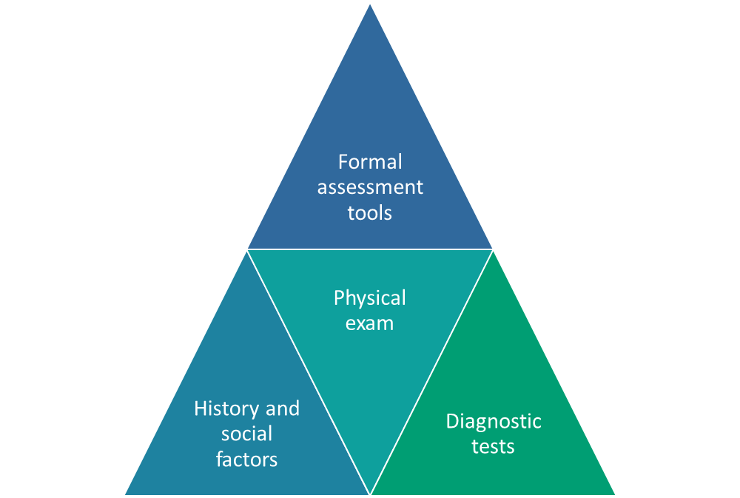

In the early stage of Alzheimer's, a person may function independently. He or she may still drive, work and be part of social activities. Despite this, the person may feel as if he or she is having memory lapses, such as forgetting familiar words or the location of everyday objects. Symptoms may not be widely apparent at this stage, but family and close friends may take notice and a doctor would be able to identify symptoms using certain diagnostic tools.

Middle-stage Alzheimer's is typically the longest stage and can last for many years. As the disease progresses, the person with Alzheimer's will require a greater level of care. During the middle stage of Alzheimer’s, the dementia symptoms are more pronounced. The person may confuse words, get frustrated or angry, and act in unexpected ways, such as refusing to bathe. Damage to nerve cells in the brain can also make it difficult for the person to express thoughts and perform routine tasks without assistance.
In the final stage of the disease, dementia symptoms are severe. Individuals lose the ability to respond to their environment, to carry on a conversation and, eventually, to control movement. They may still say words or phrases, but communicating pain becomes difficult. As memory and cognitive skills continue to worsen, significant personality changes may take place and individuals need extensive care.
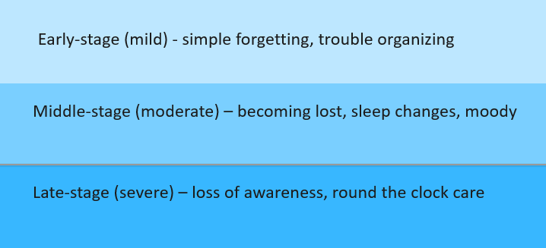
https://www.alz.org/alzheimers-dementia/stages

Ways to Support Dementia
Caregivers will need to make specific modifications in a number of areas, for example:
Communication
• Use visual cues.
• Simplify directions, but maintain respectful tone.
• Don’t correct the individual if they forget something.
• Put the most Important part of a sentence last: instead of “Get in the car, we are going to work.” Say: “We are going to work, get in the car.”
Behavior
• Time events and activities for earlier in the day.
• Calmly redirect when the individual gets agitated.
• Limit noise and distractions.
• Create a life story to engage memories and promote meaningful interactions.
Safety
• Provide a clutter free, well-lit environment.
• Lock hazardous chemicals and medications.
• Monitor and protect against wandering
• Use environmental modifications such as color contrasts to enhance vision perception or impede leaving the setting. An assessment with an Occupational Therapist can support a provider in modifying the environment.
• Reduce choking risk, for example by having a swallow assessment.
• Maintain optimum nutrition, which may require frequent small food options throughout the day.
• Monitor for secondary conditions.
Make it clear where things are
- Use clear containers or labels with pictures
- Use contrasting colors for doors and walls
- Avoid dark colors, reflective surfaces and busy patterns
- Use good lighting and natural light
- Establish consistent places for household and personal belongings
- Label dresser drawers and cabinets

Music and Dementia
Recent randomized controlled studies have shown the efficacy of music intervention in improving the well-being of individuals with dementia and their caregivers.
-Music can elicit emotions and memories and help provide a link to a person’s past.
-Music can promote interconnection with caregivers and others with dementia.
-Musical training appears to delay cognitive decline and promote brain plasticity in the elderly brain.
-Music therapy can help agitation, as well as other recreational activities.
-People with dementia respond better with individualized activities including personally preferred music.
More studies are needed to confirm the specific benefits of music therapy.

Agitation is one of the most common behavioral concerns in dementia and present in more than 50 percent of cases. This agitation, regardless of type, leads to caregiver distress and predicts nursing home placement and greater use of restraints and psychotropic drugs, causing increased cognitive decline, stroke and death. This has triggered the important need for non-pharmacologic therapies, such as music, to manage agitation. It is important to know that music therapy can help agitation but it is not necessarily better than other recreational activities, such as playing with puzzles, robotic animals, and squeezing a ball. Dementia patients respond better with individualized activities including personally preferred music.

Create a “Life Story” with the Person
Creating Life Stories with an individual with dementia can have far-reaching benefits for the individual, caregivers and the meaningful people in the individual’s life. It records important details and events from the individual’s past and present. Creating a Life Story book helps the individual recall past events, which may improve the individual’s mood as they reminisce about the past. Life Story books foster communication, strengthen relationships, and promote person centered care. Creating a Life Story involves working with the individual and people, who know him or her, to gather facts about their life, important events, interests, preferences, as well as gathering photographs or even news stories or memorabilia that help tell that individual’s unique life history.
https://shriver.umassmed.edu/wp-content/uploads/2020/12/F.CDDER_.2020-LifeStory_TAGGED.pdf

What is life story work? Essentially, it involves working with a person with dementia, family members and friends to record key moments of their past and present lives, usually in a scrapbook, photo album or video album. The book or album (which may also record current likes and dislikes and future wishes and aspirations) will play an important role in providing person-centered care and support.
Learning about people’s life stories can take many different forms. Creating a life story book with sections on childhood, teenage years, working life and family life can be enjoyable for the person with dementia and also for their family. Many imaginative life story programs exist: some use collages, others use pictures, photographs or objects to evoke positive recall of days gone by. Sometimes these special items are placed in a memory box.
It is often possible to find out something simple from the person’s past such as where they lived or what they did for a living. Using this as a starting point, you can then reminisce with them using pictures and objects relating to this part of the person’s life. As the process continues more and more memories will be recovered and new ones will emerge. This helps family, friends and care workers to build up a unique picture of the person – and helps them to communicate with you. As the dementia progresses, life story work can play an increasingly important role in helping to stimulate conversation, especially when meeting the person for the first time.

https://www.scie.org.uk/dementia/after-diagnosis/communication/person.asp#:~:text=What%20is%20life%20story%20work,photo%20album%20or%20video%20album.

Resources:
The National Task Group on Intellectual Disabilities and Dementia Practices https://www.the-ntg.org/publications
The Eunice Kennedy Shriver Center https://shriver.umassmed.edu/programs/cdder/aging_idd_education/
The Alzheimer's Association https://www.alz.org/
The Social Care Institute for Excellence https://www.scie.org.uk/dementia/
Practical Neurology Music and Dementia: an Overview by Ronald Devere, MD
https://practicalneurology.com/articles/2017-june/music-and-dementia-an-overview

